


PROJECT REPORT

AI BLOGNEST API

YEAR : 2025 – 2026
COLLEGE NAME : K.C.S KASI NADAR COLLEGE OF ARTS & SCIENCE CODE : UNM203
DEPARTMENT : COMPUTER SCIENCE PROGRAM : B.C.A
SEMESTER V
PROJECT SUBMITTED TO: UNIVERSITY OF MADRAS /
VETRI THIRAN PAYIRCHI THITTAM
COURSE NAME : AI Augmented Backend Development with Node JS and MongoDB
TEAM LEADER:
RAKESH.R
MEMBERS:
- RAHIM USHAMADEEN.K
- PRABANJAN.S.K
- KUMARAVEL.N V

GUIDED BY: Mrs. R.PADMADEVI

SPOC NAME: Dr.K. LALITHAKAMESWARI

BONAFIDE CERTIFICATE

Certified that this report titled “AI BLOGNEST API” is a

bonafide record of the Naan Mudhalvan Project work done by RAKESH R (UNM ID unm203212401477), RAHIM USHAMADEEN K (UNM ID unm203212401474), PRABANJAN S K(UNM ID unm203212401470), and
KUMARAVEL NV (UNM ID unm203212401457), under our supervision and guidance, towards the partial fulfillment of the requirements for the award of the Degree of
B.C.A of K.C.S. Kasi Nadar College of Arts & Science

Date:

Training Faculty External Examiner

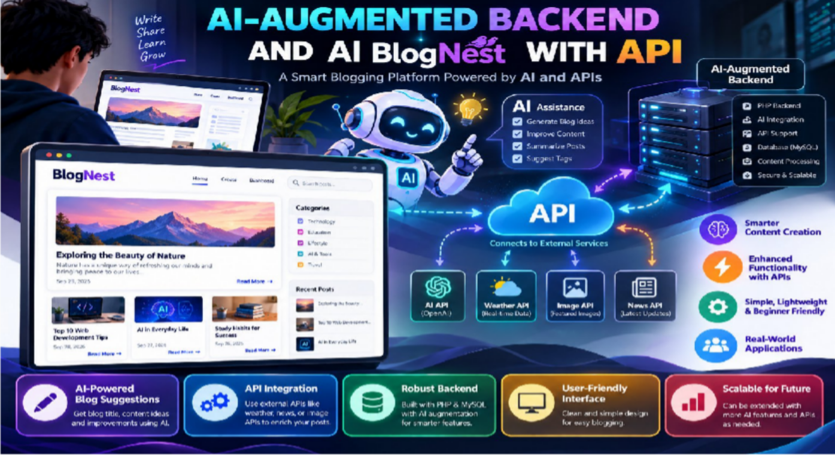
AI-ARGMENTED BACKEND AND AI BLOGNEXT WITH API

Introduction
- Definition of a Blog A blog is an online journal or informational website where content is published in reverse chronological order. It allows individuals or groups to share ideas, tutorials, opinions, or updates with a wide audience.
- Purpose of BlogNest BlogNest is designed as a simple PHP-based blogging platform. Its primary purpose is to help beginners learn web development while creating a personal space for writing and sharing content.
- Why Blogging Matters Today In the digital age, blogs are powerful tools for communication. They allow people to express themselves, build communities, and share knowledge globally.
- Educational Value of BlogNest This project is not just about publishing posts — it’s a learning exercise. By building BlogNest, students gain hands-on experience with HTML, PHP, and basic database handling.
- Target Audience BlogNest is aimed at beginners in web development, students working on academic projects, and individuals who want a lightweight blogging solution without complex frameworks

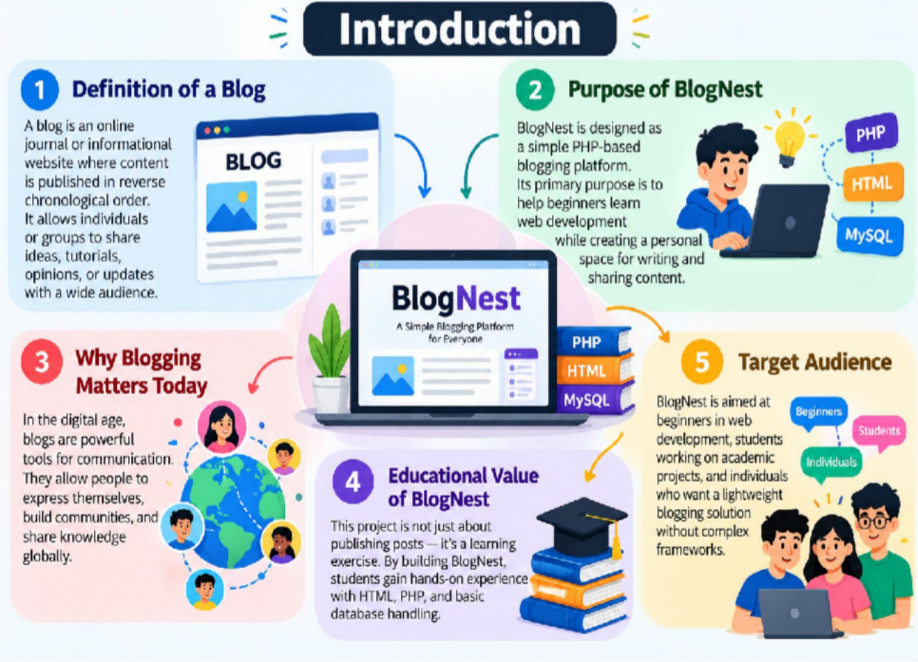
Project Vision
- Simplicity First BlogNest is built to be lightweight and easy to understand. The vision is to provide a platform that beginners can grasp quickly without being overwhelmed by complex frameworks.
- Educational Purpose The project is designed as a learning tool. By working with BlogNest, students gain practical knowledge of PHP, HTML, and basic database handling — skills that form the foundation of web development.
- Accessibility for All BlogNest aims to be accessible to anyone with basic computer knowledge. It doesn’t require advanced technical expertise, making it suitable for students, hobbyists, and small communities.
- Scalability in Mind Although simple at its core, BlogNest is envisioned as a project that can grow. Features like authentication, comments, and responsive design can be added gradually, showing learners how projects evolve.
- Community-Driven Growth The vision includes encouraging collaboration. BlogNest can be shared, improved, and expanded by contributors, making it a potential open-source project.
- Practical Application BlogNest is not just theoretical — it can be used as a real blogging platform for personal diaries, tutorials, or community updates.

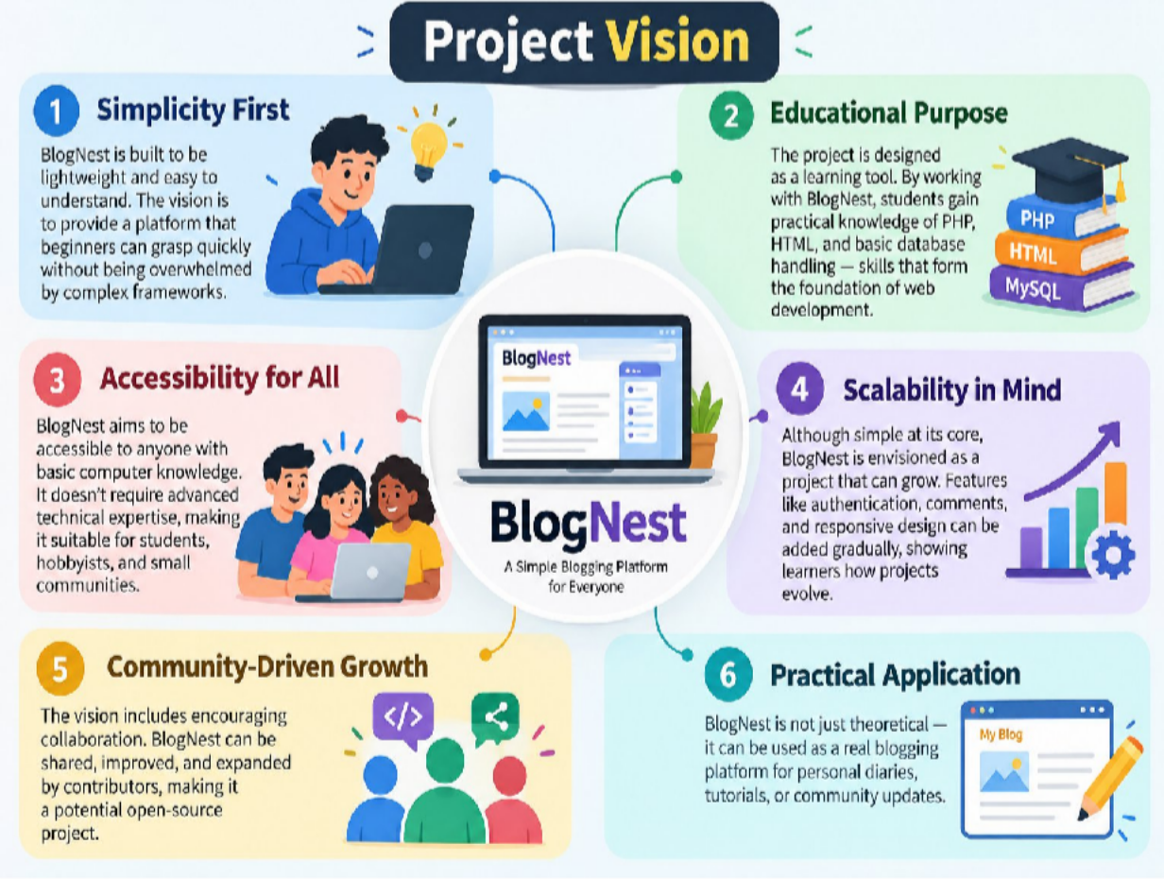
Usage Guide
Users can:
  - View posts on the homepage.
  - Add new posts through a form.
  - Edit or delete posts via the dashboard. This workflow makes it easy to manage content without advanced tools.

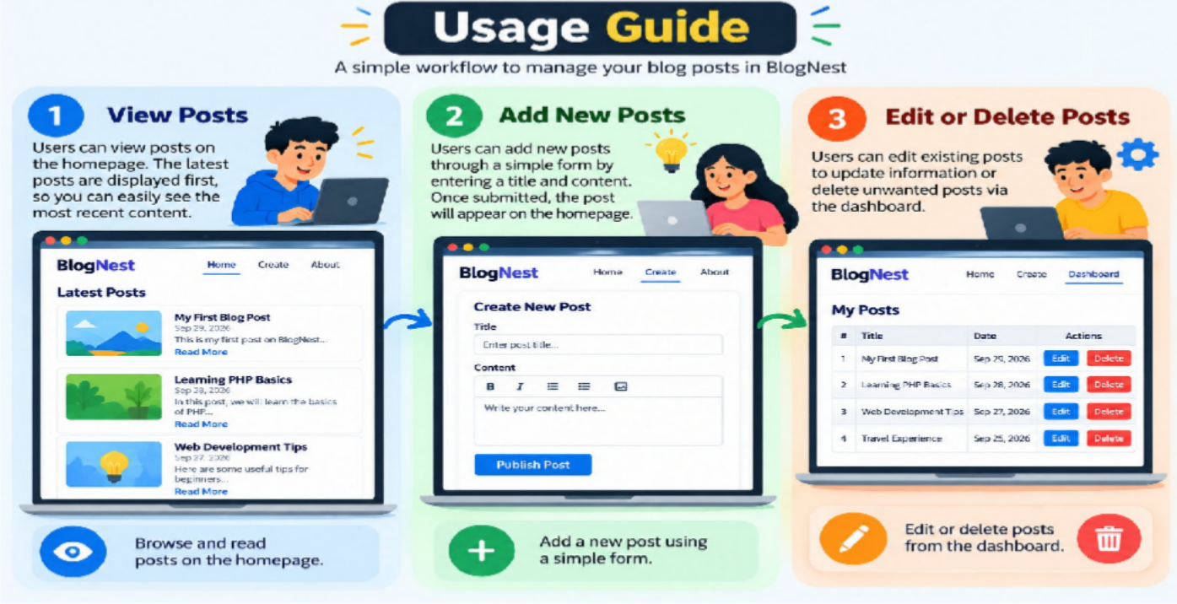
Features (Expanded)
- Post Creation Users can create new blog posts by entering a title and content through a simple form. This is the core functionality of BlogNest.
- Post Editing Existing posts can be modified to correct mistakes or update information. This ensures content stays relevant.
- Post Deletion Users can remove unwanted posts from the system, keeping the blog clean and organized.
- Reverse Chronological Order Posts are displayed with the newest at the top, making it easy for readers to see the latest updates first.
- Simple Homepage Layout The homepage shows a list of posts with titles and snippets, giving readers a quick overview of available content.

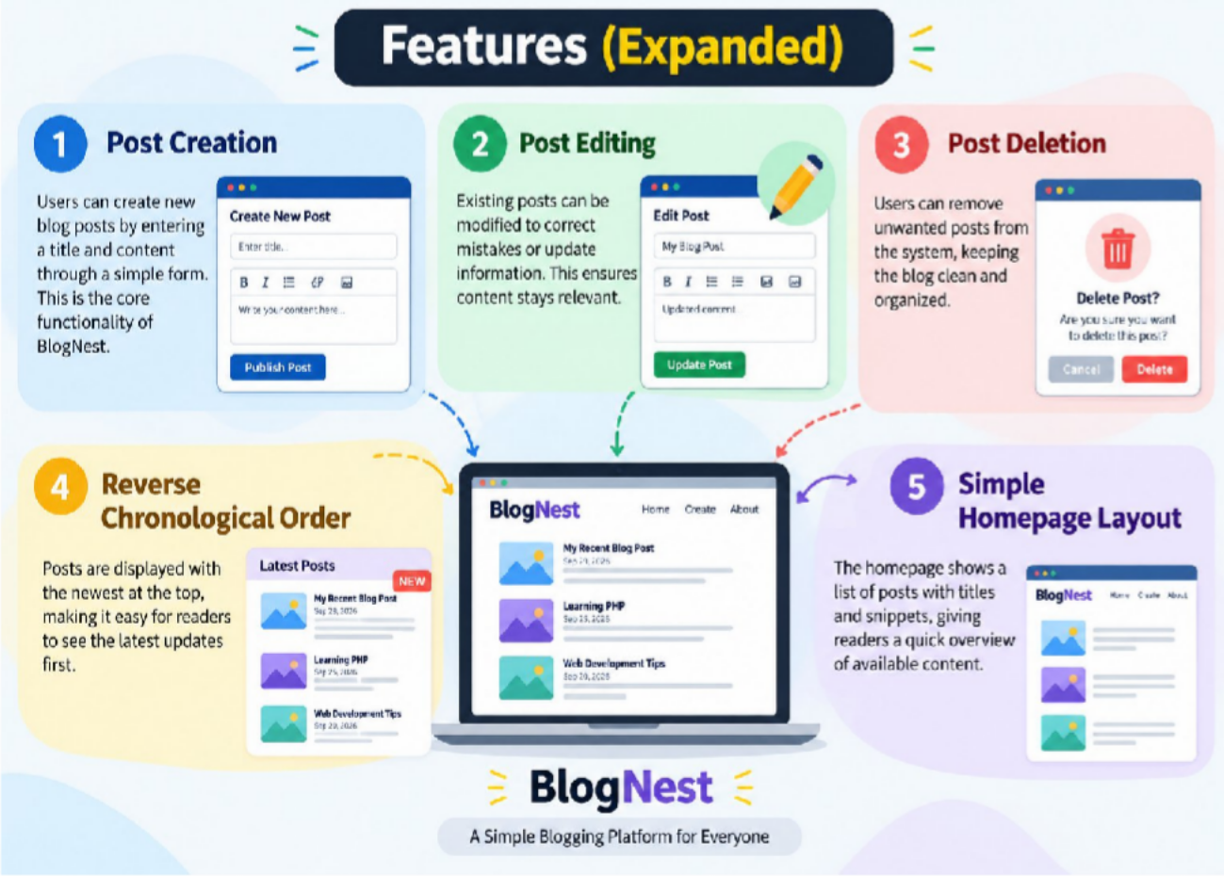
Advantages
- Beginner-Friendly The code structure is simple, making it easy for new learners to understand PHP and HTML without confusion.
- Lightweight BlogNest avoids heavy frameworks, so it runs smoothly even on basic servers and loads quickly.
- Expandable The modular design allows new features (like comments, authentication, or search) to be added step by step.
- Educational Value It teaches essential web concepts such as form handling, server-side logic, and data flow.
- Quick Setup Installation is straightforward — just copy files to a server and run index.php.
- Customizable Users can easily add CSS or JavaScript to improve design and interactivity.
- Portable Since it’s built with PHP, BlogNest can run on any server that supports PHP, making it widely usable.
- Low Resource Usage It doesn’t demand high computing power, so it works well even in low-resource environments.

- Practical Application It can be used as a real blogging platform for personal diaries, tutorials, or community updates.
- Encourages Creativity Users can experiment with layouts, add features, and innovate freely.
- Cross-Platform Usability Works on Windows, Linux, or Mac servers, as long as PHP is installed.
- Fast Performance Because it’s lightweight, pages load quickly, improving user experience.
- Step-by-Step Learning Beginners learn gradually — starting with basic posts and moving toward advanced features.
- Community Collaboration BlogNest can be shared and improved by others, making it a potential open-source project.
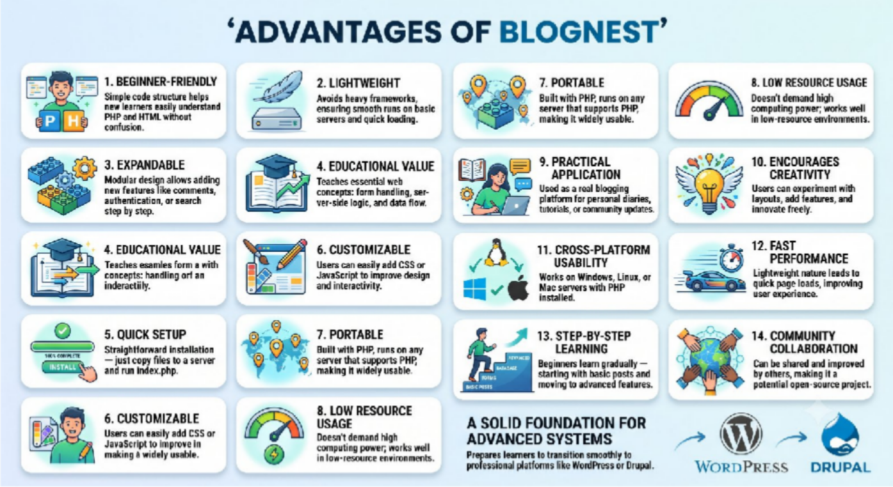
- Foundation for Advanced Systems It prepares learners to transition smoothly to professional platforms like WordPress or Drupal.

Disadvantages
Limited Styling and Design The project uses plain HTML without CSS, so the interface looks very basic and lacks modern design appeal.
- Basic Security Features Only There is no strong input validation or protection against attacks like SQL injection, making it vulnerable in real-world use.

- Manual Database Setup Required Users must configure MySQL manually, which can be difficult for beginners unfamiliar with database management.
- No Advanced Features Like Media Uploads Yet Currently, BlogNest only supports text posts. Features like image or video uploads are missing.
- No User Authentication Anyone can add or edit posts without logging in, which limits control and privacy.
- • No User Authentication Anyone can add or edit posts without logging in, which limits control and privacy.
- • No Comment System Readers cannot interact with posts, reducing engagement and community building.
- • Limited Scalability The current design works for small blogs but may struggle with large amounts of content or traffic.
- • No Search Functionality Users cannot search for posts by keywords, making navigation harder as the blog grows.
- • No Categories or Tags Posts cannot be grouped or organized, which limits usability for larger blogs.

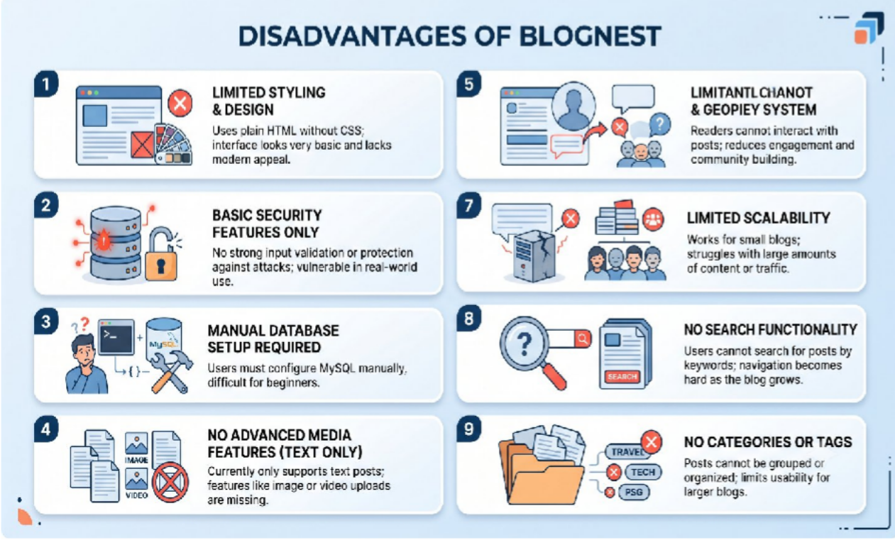
Real-World Applications

- A Personal Diary BlogNest can serve as a digital diary where individuals record their daily thoughts, experiences, or reflections. Since it’s lightweight and simple, users don’t need advanced technical skills to maintain their own private or public journal.

- A Student Project Students can use BlogNest as an academic project to demonstrate their knowledge of PHP and HTML. It’s a practical way to showcase coding skills, file handling, and database integration in a structured format.
- A Tutorial Sharing Platform BlogNest can be used to publish tutorials or learning materials. Teachers, mentors, or learners can share step-by-step guides, making it a useful educational resource for communities or classrooms.
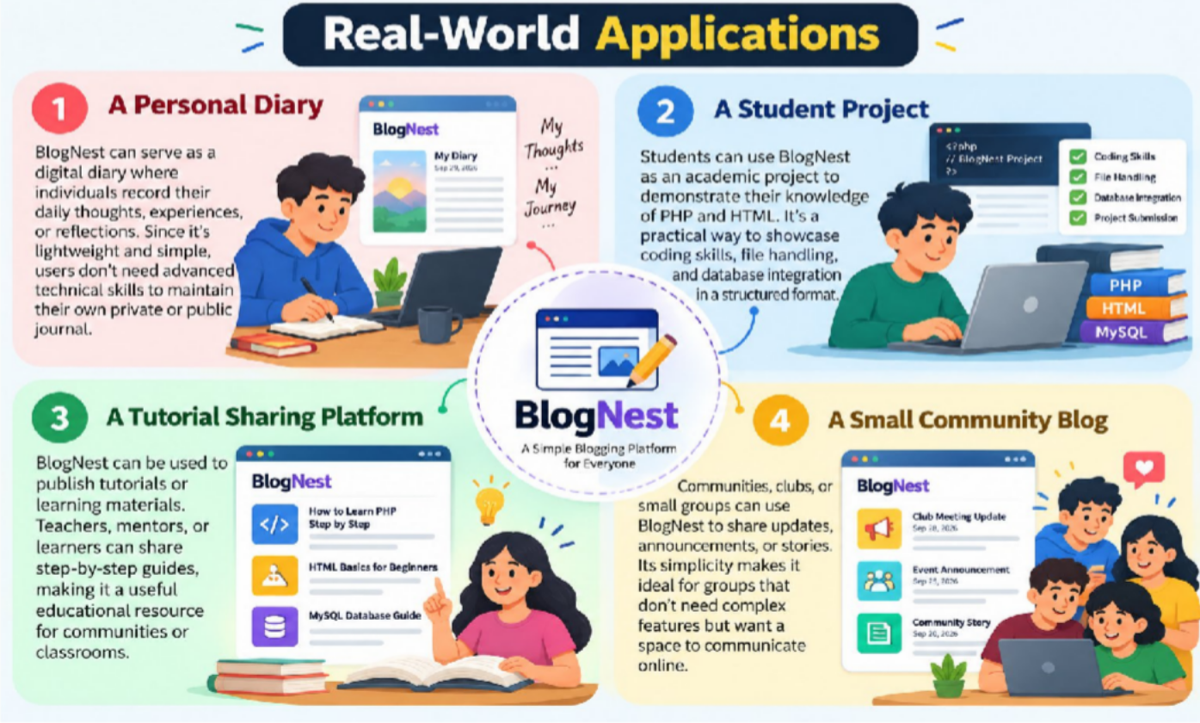
- A Small Community Blog Communities, clubs, or small groups can use BlogNest to share updates, announcements, or stories. Its simplicity makes it ideal for groups that don’t need complex features but want a space to communicate online.

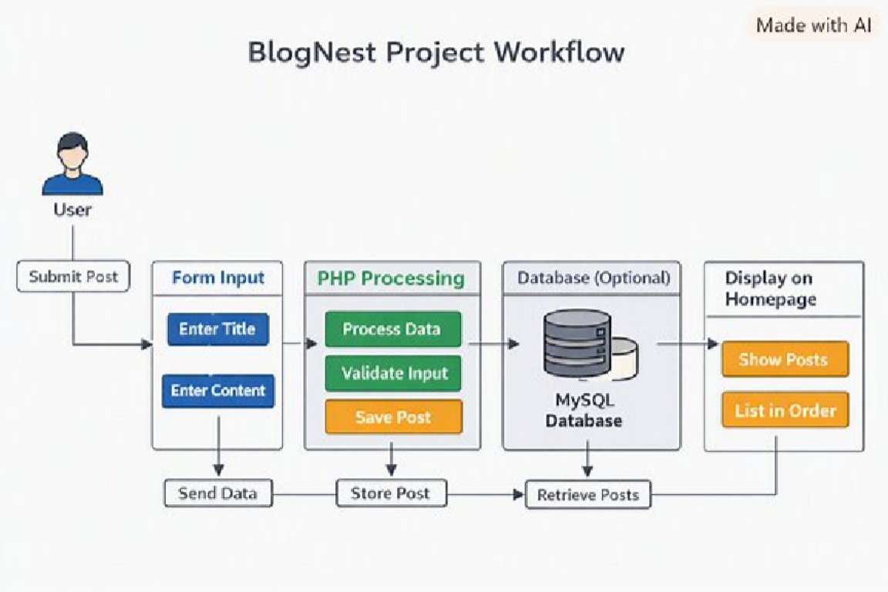

The diagram shows the workflow step by step:
  - User → submits a post
  - Form Input → title + content fields
  - PHP Processing → handles data, validates input, saves post
  - Database (Optional) → stores or fetches posts
  - Display on Homepage → shows posts in order
This flowchart visually explains how BlogNest works, from user input to final display.

Entity-Relationship (ER) Diagram Description
The underlying document structure manages several collections bound by logical application references:

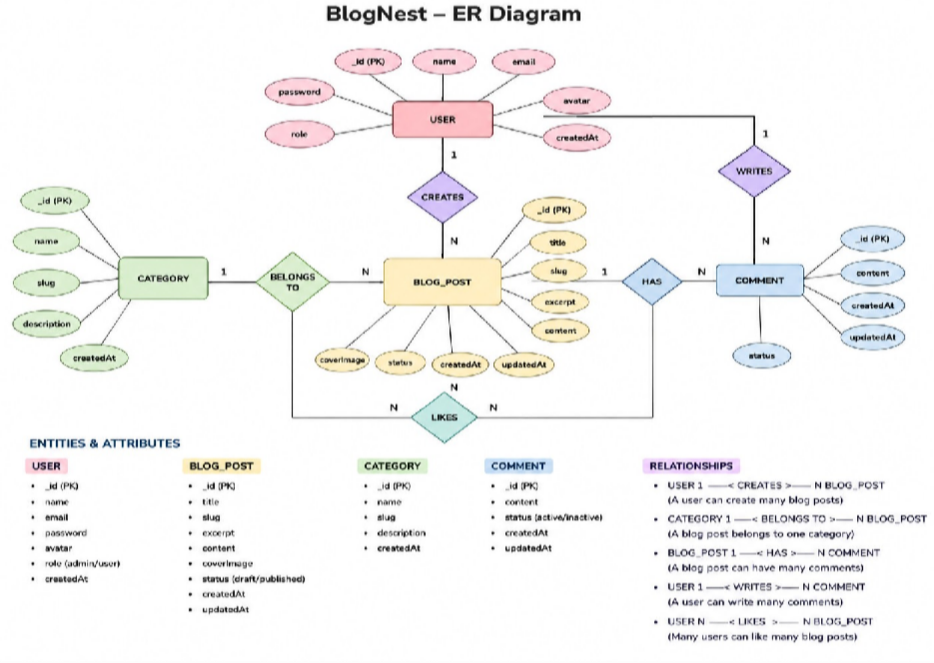

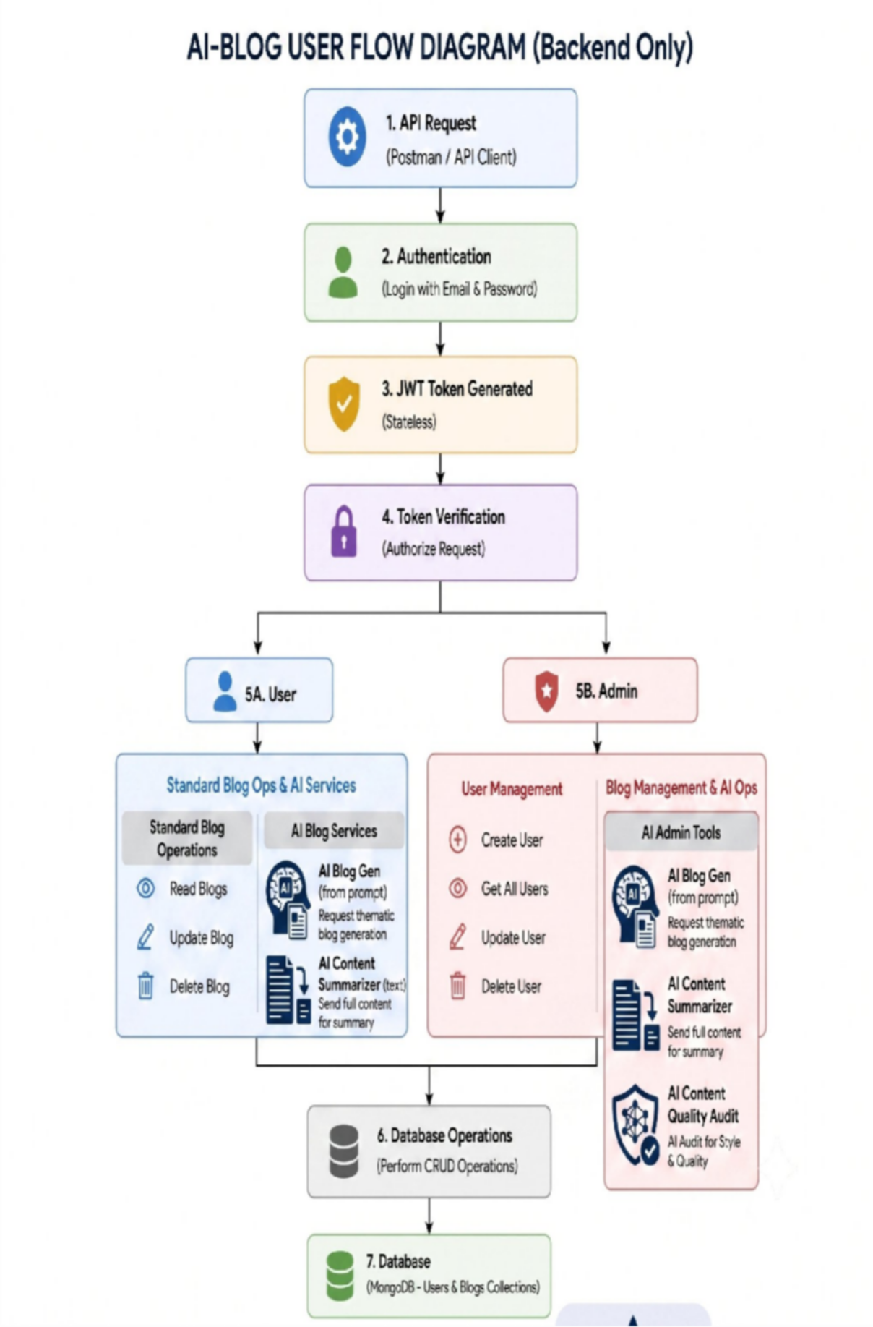
MVC Architecture Pattern
The system architecture structures its source configuration layers around the Model-View-Controller design pattern to completely decouple components:

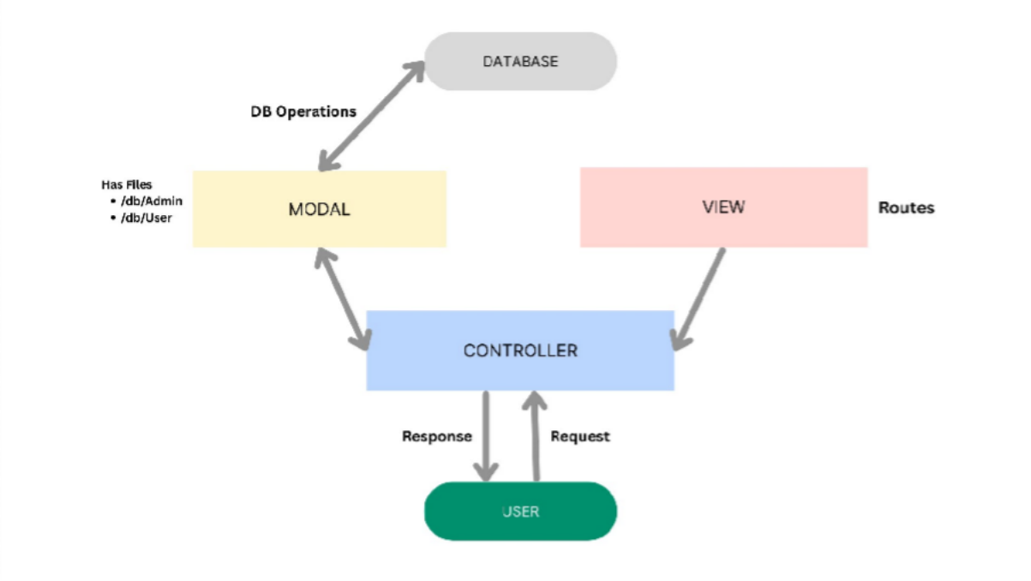

Model Layer (Data Blueprint)
Defines structure blueprints via strongly enforced Mongoose schemas mapping explicit fields into raw collection items inside MongoDB. It sets default states, indexing rules, and transformation parameters before validation persistence occurs.
Controller Layer (Execution Matrix)
The intermediary brain of the ecosystem. It captures request vectors from the execution routes, checks structural request constraints, delegates processing workflows directly to models, and packages the resultant output into standard JSON return arrays.
View Layer (Routing Network Interface)
In this pure headless backend service context, standard user-interface template views do not exist. Instead, the interface layer lives as an API Routing Layer. It links network requests on specified paths directly to their associated controller handler logic maps.

Epic2: Project Setup and Configuration

Creating project folder

- Create a new folder with your <project name>.

- Inside that folder create one new folders.
- Name another one as Server.

- Now open that folder in VS Code.

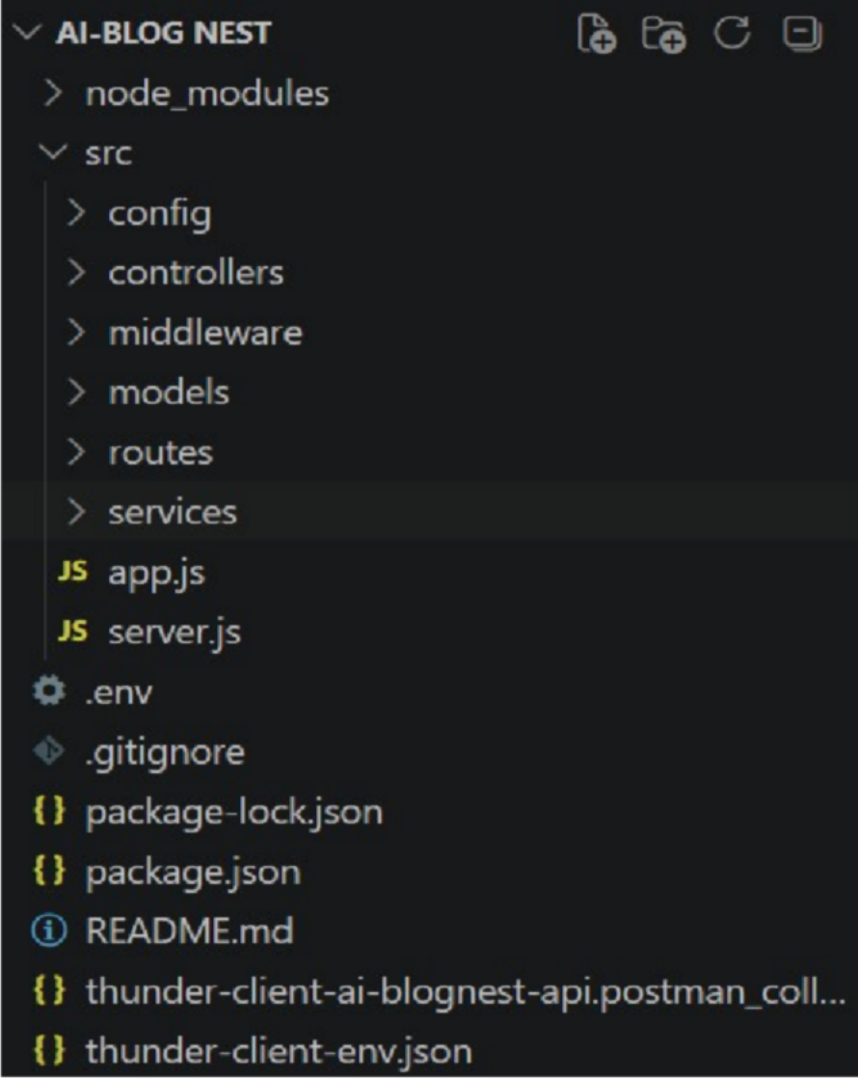

Server setup (npm init)
  - Open Server folder in terminal of VScode.
    - npm init -y ○ Create files:
    - server.js ○ Create folders: ■ models
    - controllers
    - routes

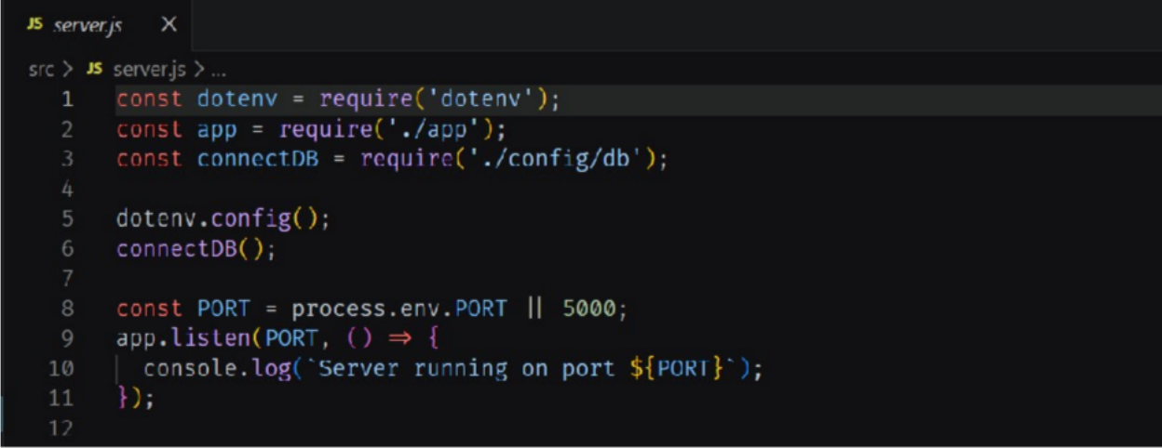
Epic 3: Backend Development Server.js

App.js
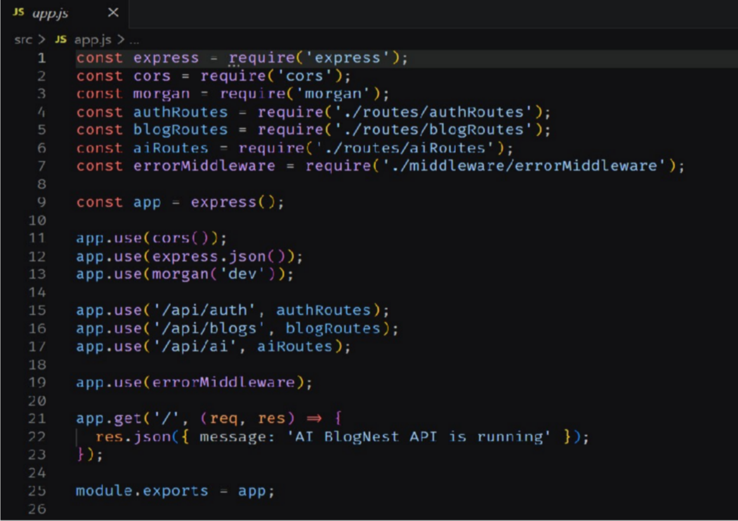

Epic4: Database Configuration

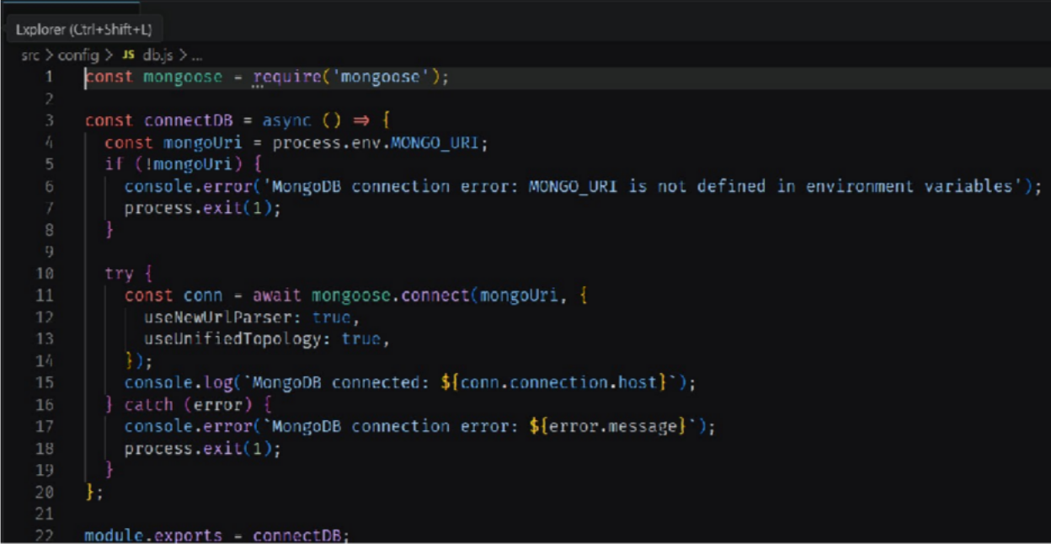
DB Connection:-
- Configure MongoDB:

  - Install Mongoose.
In your Node.js project directory, run:
npm install mongoose ● Create database connection.
  - Create Schemas & Models.

Create Database connection:
Now, make sure the database is connected before performing any of the actions through the backend. The connection code looks similar to the one provided below
Mongoose Schema Definitions
- Identity Resource Document Schema (schemas/userModel.js) Enforces field criteria validations on incoming database creations:

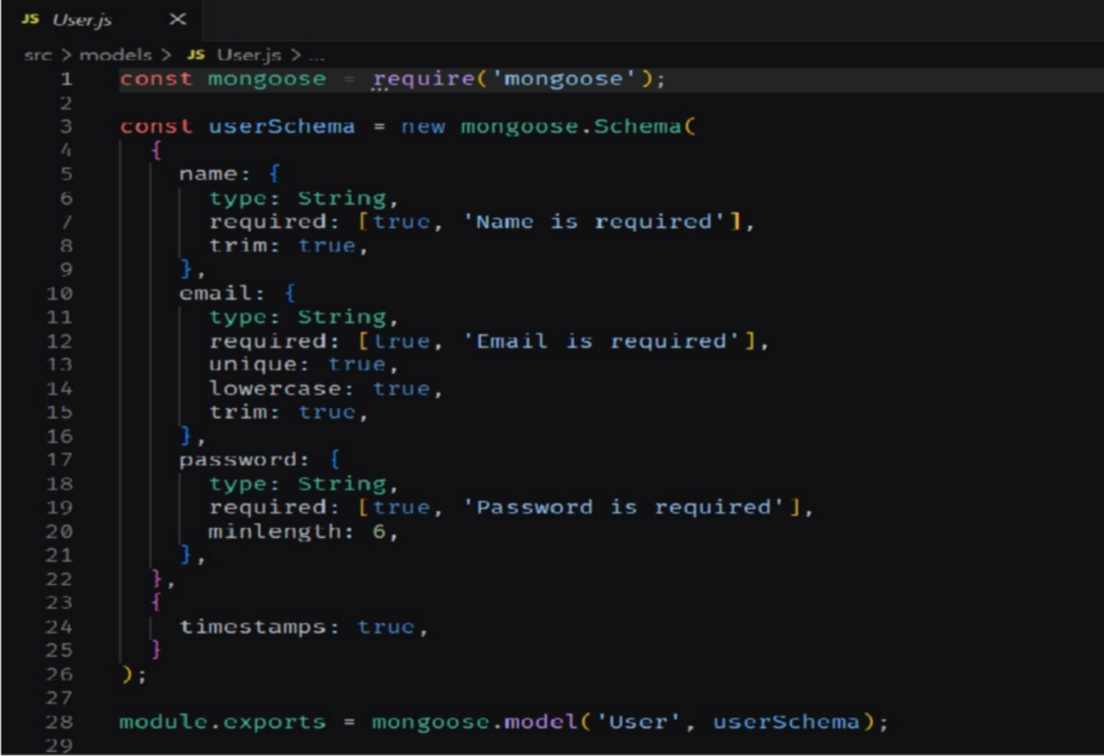
Epic 5: Project Executions:
  - Install Postman or ThunderClient (VS Code extension).

  - Start the backend server:
“npm start”

API Testing

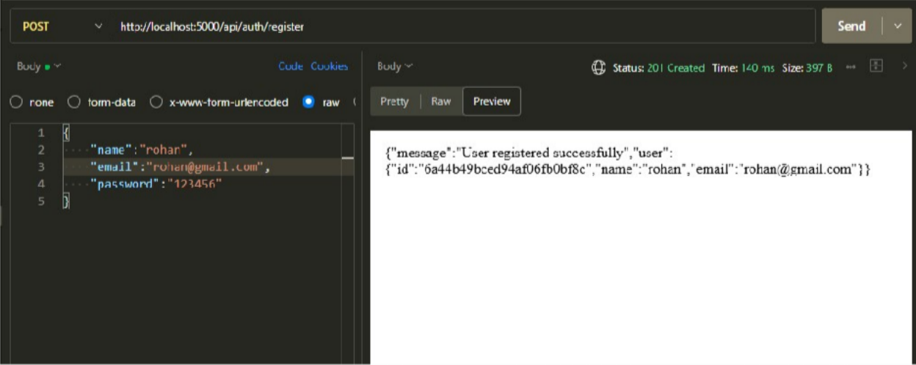
User Registration :
User Login:

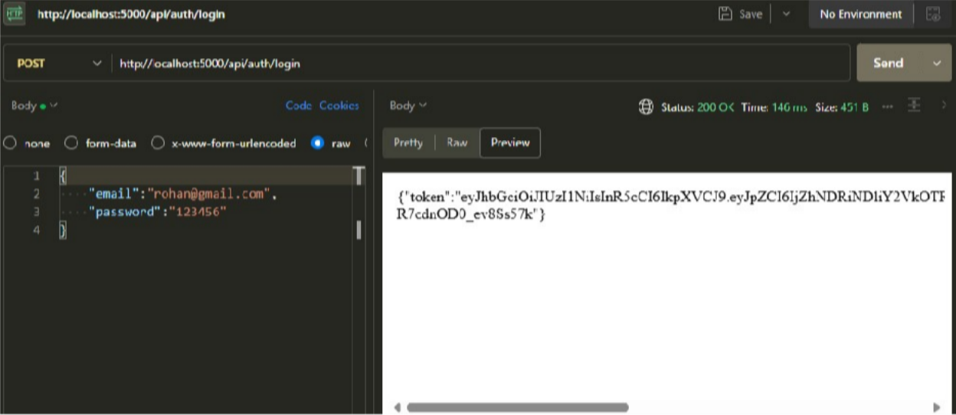
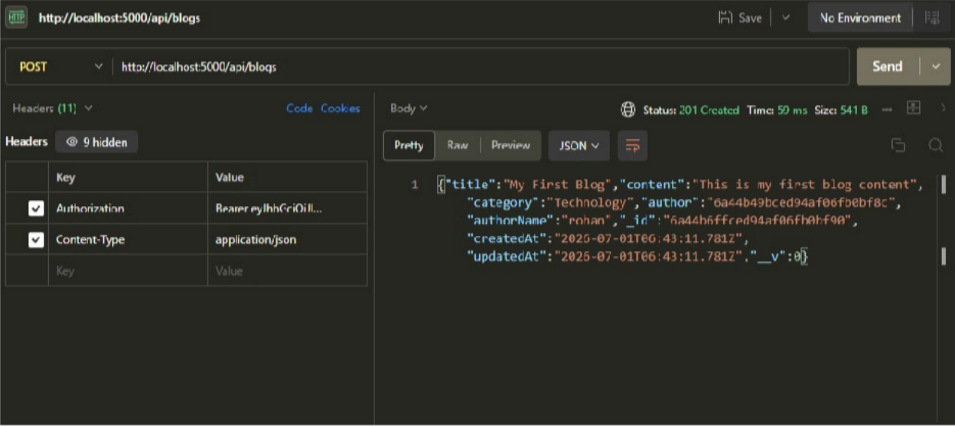
Create Blogs :
Fetch Blogs :
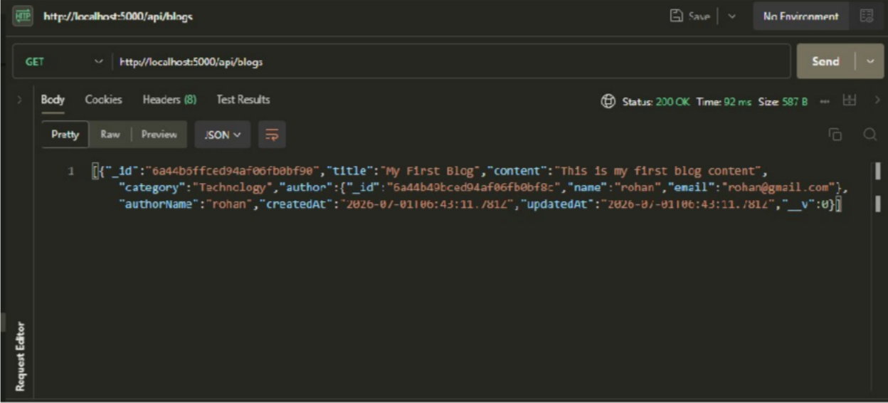

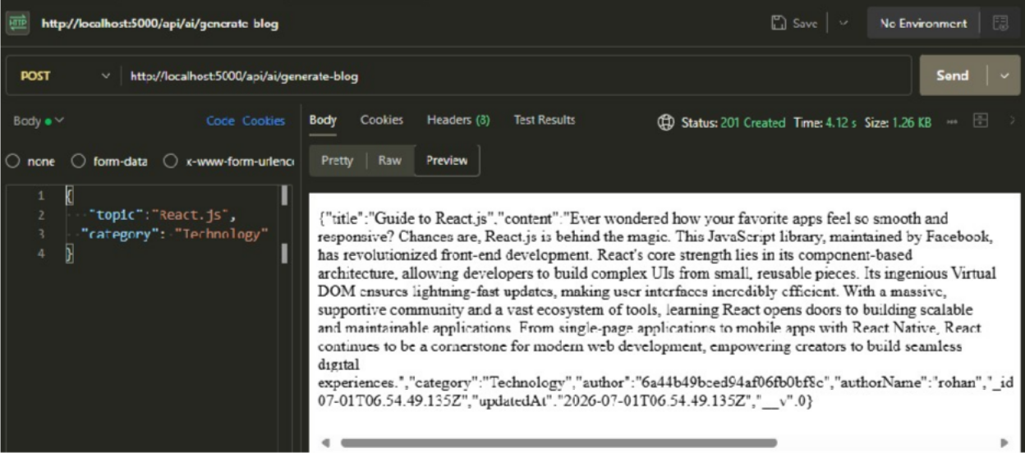
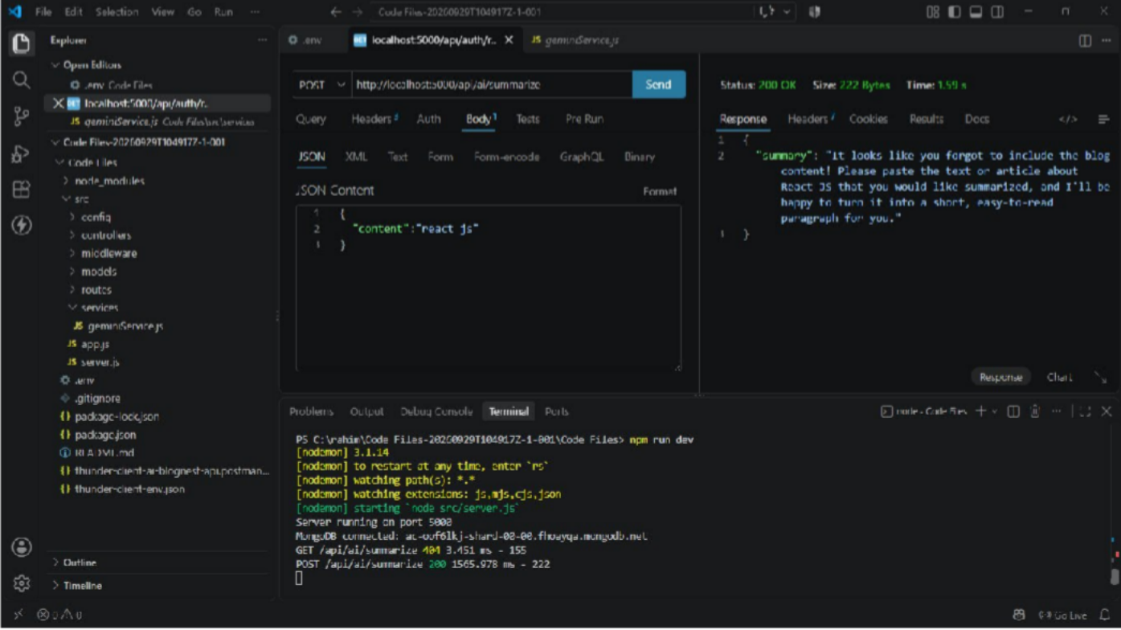
Generate AI blogs :
Summarize Blogs :

AI BLOGNEST GITHUB LINK: https://github.com/rakeshr2882006-pixel/AI-BlogNest-API.git
DEMO VIDEO OR OUTPUT VIDEO LINK:
https://drive.google.com/file/d/1p_LRe7FnEtHq8wHda48QK83YRZCeQ2Dk/view?usp=sha ring

